

**Tribhuvan University**

**Faculty of Humanities and Social Science**

**“INFINITY SERVICE”**

**A PROJECT REPORT**

**Submitted to**

**Department of Computer Application**

**Swoyambhu International College**

***In partial fulfillment of the requirements for the Bachelors in Computer Application***

**Submitted by**

Dharmendra Kumar Ram, Bibek Chaudhary

Regd. No. 6-2-503-23-2020, 6-2-503-20-2020

August 2023

Under the supervision of

**Sujit Gyawali**



**Tribhuvan University**

**Faculty of Humanities and Social Science**

**Swoyambhu International College**

**Supervisor’s Recommendation**

I hereby recommend that this project prepared under my supervision by Dharmendra Kumar Ram and Bibek Chaudhary “**Infinity Service”** in partial fulfillment of the requirements for the degree of Bachelor of Computer Application is recommended for the final evaluation.

**SIGNATURE**

Sujit Gyawali

**SUPERVISOR**

Department of BCA

Swoyambhu International College

Lagankhel, Lalitpur



**Tribhuvan University**

**Faculty of Humanities and Social Science**

**Swoyambhu International College**

**LETTER OF APPROVAL**

This is to certify that this project prepared by Dharmendra Kumar Ram and Bibek Chaudhary “**Infinity Service”** in partial fulfillment of the requirements for the degree of Bachelor in Computer Application has been evaluated. In our opinion it is satisfactory in the scope and quality as a project for the required degree.

|  |  |
| --- | --- |
| ………………………..………………..  **Signature of Supervisor**  **Sujit Gyawali**  Lecturer  Swoyambhu International College  BCA | ……………………………………………  **Signature of Coordinator**  **Raj Kumar Sah**  Coordinator  Swoyambhu International College  BCA |
| …………………………………………  **Signature of Internal Examiner** | ……………………………………………  **Signature of External Examiner** |

# ABSTRACT

At present, people do not need to visit physical shops due to online system in the market. This project ensures an online booking system where users do not have to visit the workshops physically for booking appointments. The users can simply fill up forms to schedule booking appointments to their trusted service provider at their convenience.

Moreover, the bike owners can track their servicing and maintenance date and this website helps to remind them for the upcoming servicing date. In addition, the users can order or buy their essential spare parts and products at the time of booking an appointment.

**Keywords:** Online Booking, Digital Record Keeping, User-friendly Interface, Servicing, Maintenance.

# ACKNOWLEDGEMENT

First and foremost, we would really like to thank our Project Management Teacher (**Sujit Gyawali**) who guided in doing this project. He supplied with valuable recommendation and helped in hard periods. His motivation and assist contributed relatively to a hit finishing touch of the project. Besides, we would really like to thank all the lecturers who helped via way of means of giving us recommendation and offering the system which is needed. Also, I would really like to thank my own circle of relatives and friends for his or her help. Without that help we couldn’t have succeeded in finishing this project. At last, however now no longer in least, we would really like to thank everybody who helped and stimulated to paintings in this project.

Dharmendra Kumar Ram and Bibek Chaudhary

BCA, 4th Semester

Swoyambhu International College

# TABLE OF CONTENTS

ABSTRACT i

ACKNOWLEDGEMENT ii

TABLE OF CONTENTS iii

LIST OF ABBREVIATIONS v

LIST OF FIGURES vi

LIST OF TABLES vii

CHAPTER 1: INTRODUCTION OF THE PROJECT 1

1.1. Introduction 1

1.2. Problem Statement 1

1.3. Objectives 2

1.4. Scope and Limitation 2

1.4.1. Scope 2

1.4.2. Limitations 2

1.5. Report Organization 3

CHAPTER 2: BACKGROUND STUDY AND LITERATURE REVIEW 4

2.1. Background Study 4

2.2. Literature Review 4

CHAPTER 3: SYSTEM ANALYSIS AND DESIGN 6

3.1 System Analysis 6

3.1.1. Requirement Analysis 7

3.1.2 Feasibility Study 9

3.1.3. Data Modeling (ER-Diagram) 12

3.1.4. Process Modeling (DFD) 13

3.2 System Design 16

3.2.1 Architectural Design 16

3.2.2 Database Schema Design 17

3.2.3 Interface Design (UI Interface/Interface Structure Diagrams) 18

3.2.4 Physical DFD 20

CHAPTER 4: IMPLEMENTATION AND TESTING 23

4.1. Implementation 23

4.1.1. Tools Used 23

4.1.2. Implementation Details of Modules 23

4.2. Testing 25

4.2.1 Test Case for Unit Testing 25

4.2.2 System Testing 30

CHAPTER 5: CONCLUSION AND FUTURE RECOMMENDATIONS 31

5.1. Lesson Learnt / Outcome 31

5.2. Conclusion 31

5.3. Future Recommendations 31

REFERENCES 32

APPENDICES 33

# LIST OF ABBREVIATIONS

|  |  |
| --- | --- |
| **Abbreviation/Acronym Description** |  |
| IS | Infinity Service |
| HTML | Hypertext Markup Language |
| CSS | Cascading Style Sheet |
| PHP | Hypertext Preprocessor |
| XAMPP | Cross-platform, Apache, Maria DB(MySQL), PHP and Perl |
| MS | Microsoft |
| MYSQL | Structured Query Language |
| DFD | Data Flow Diagram |
| CRUD | Create, Retrieve, Update & Delete |

# LIST OF FIGURES

Figure 3-1: Waterfall Software Development Model of IS 6

Figure 3-2: Use Case Diagram of IS 8

Figure 3-3: Gantt Chart of IS 11

Figure 3-4: ER Diagram of IS 12

Figure 3-5: Context diagram for IS 13

Figure 3-6: DFD level 1 diagram for ordering products 14

Figure 3-7: DFD level 1 diagram for booking appointments 15

Figure 3-8: Three-Tier Architecture of IS 16

Figure 3-9: IS Schema Design of IS 17

Figure 3-10: Index Design of IS 18

Figure 3-11: Service Section in Index page of IS 18

Figure 3-12: Our Product Section in Index page of IS 19

Figure 3-13: Footer Section in Index page of IS 19

Figure 3-14: Admin Dashboard Design of IS 19

Figure 3-15: Physical DFD for user register 20

Figure 3-16: Physical DFD for user login 20

Figure 3-17: Physical DFD for bookings 21

Figure 3-18: Physical DFD for Category 21

Figure 3-19: Physical DFD for Product 21

Figure 3-20: Physical DFD for Order 21

# LIST OF TABLES

Table 3-1: Technical Feasibility Study Table 9

Table 3-2: Scheduling Table of IS 10

Table 4-3: Register page Test Case 25

Table 4-4: Login page Test Case 27

Table 4-5: Service and Maintenance page Test Case 28

Table 4-6: Order page Test Case 29

Table 4-7: System Test Case 30

# CHAPTER 1: INTRODUCTION OF THE PROJECT

## Introduction

Infinity Service (IS) is an online platform for the bike owners that helps to connect with service providers or workshops. This project is a single-vendor project where service providers are admins and all the biker owners are the end-users. This online-based website ensures that bikers can make easier online appointments for bike servicing and maintenance by their trusted service provider.

The main aim of the project is to develop an online booking application for small workshops. This project provides a platform for the bikers in managing their time while going for bike service or maintenance. Most of the workshops run manually without any fixed guarantee of time. This results in long queue in the workshops. Thus, to reduce these traffics this project is designed with user-friendly interfaces that allows users to make booking appointments for bike servicing and maintenance, all from the convenience of their smartphone.

Similarly, this website also provides feature to buy different spare parts of bike specially used while servicing. This facility of helping in installation of spare parts is the secondary trade dealership of this project.

Moreover, this project ensures a convenient way of digital record keeping of details about users with their servicing time which reminds them for next servicing in appropriate time, and workshops with an accurate count of the products in the shop.

## Problem Statement

* The existing system has a complex interface with lot of facilities (booking appointments, bill book renews, old bikes trading) integrated in one site that can cause confusion in booking appointments for bike servicing and maintenance.
* Since, the system asks workshops to merge and work for them it can loss self-identification of small workshops’ owners who want to run their own business.

## Objectives

The objectives of this online booking system are mentioned as follows:

1. To provide online platform to make booking appointments for bike servicing and maintenance easily and quickly.
2. To provide digital record keeping system of the details about users, bikes, inventories of spare parts.

## Scope and Limitation

### Scope

1. This project’s aim is to automate the system, and develop a user-friendly interface to select a convenient time and date for booking appointments for bike servicing.
2. Workshops can have access to the dashboard to view and manage the incoming appointments requests that helps to control the traffic in the weekends.
3. As the system records the details about the time and date of bike servicing, it helps in reminding the customers for upcoming appointments.
4. The system helps to keep digital records of the purchased and sold inventories of spare parts and accessories.

### Limitations

1. Since the system is an online-based website, it depends on internet connectivity.
2. Basic knowledges such as English language are required to operate the system.
3. There is no add to cart option in the system which can cause inconvenient in buying more spare parts at once.
4. The quality of the spare parts cannot be guaranteed by the system which can sometimes cause buying duplicate products.

## Report Organization

The report consists of five different chapters. First of all, the introduction of the project is described in the first chapter. The second chapter includes the background study and literature review of existing related system. System analysis and design of the project is stated in the chapter three. This includes the requirement analysis, feasibility study, architectural design, process modeling (DFD), etc. Likewise, in the fourth chapter of this report implementation and testing are performed with different test cases. The last chapter explains the conclusion of the project with future recommendations.

# CHAPTER 2: BACKGROUND STUDY AND LITERATURE REVIEW

## Background Study

Nowadays, the bike owners need to physically visit the workshops to book an appointment to reliable and convenient bike servicing and maintenance. All the activities of booking an appointment are performed manually. The bike owners have to wait in long queue for their turn. This makes unnecessary time waste and can hamper other works. Thus, this project helps to provide a platform for users to book bike servicing and maintenance quickly for proper time management. The users use the system to schedule an appointment for essential type of services by filling up form.

Moreover, there is paper-based system in workshops to record inventories list. This project also facilities for recording these inventories of spare parts digitally. The service providers can also add, update, view the products, and can delete unwanted products. This system also provides a facility of ordering the spare parts while servicing. It gives a user convenient interface to order the products.

In addition, this project has a database to store all the records of the users’ details, bookings details, order details. It provides far reasonable storage facility than paper-based system.

## Literature Review

From research, we found that there are very few online service booking platforms. Most of the workshops still use paper work to book an appointment. Similarly, we found that there are some online service bookings website like Third Wheel [1] that provide online servicing appointment. This website offers to merge with them as common name. Thus, this can cause loss of identity of small workshop’s owners who want to run their own serving center.

Along with identity issues, we found that this website has not limited with online booking service but also to renew the bikes’ blue book and sell old bikes as well. So, this makes more complex interface of the website and can create less user interactions.

Thus, our project is concern of eliminating the errors in the above system by focusing specially in online booking and providing a better user experience with greater user interaction. This project is based on CRUD operation and our team will try to provide a better and upgraded software than those in the market now.

# CHAPTER 3: SYSTEM ANALYSIS AND DESIGN

## 3.1 System Analysis

However, this project can be developed using different software development models, but we have used traditional waterfall model of SDLC.

This methodology is a linear, sequential approach to the software development lifecycle (SDLC) that is popular in software engineering and product development focusing on individual components of the system. This project is a small-scale project with limited time frames to work within.

The stages that are followed during the project development are as below:

1. Requirements of the project
2. Design of the system
3. Implementation
4. Verification of the system
5. 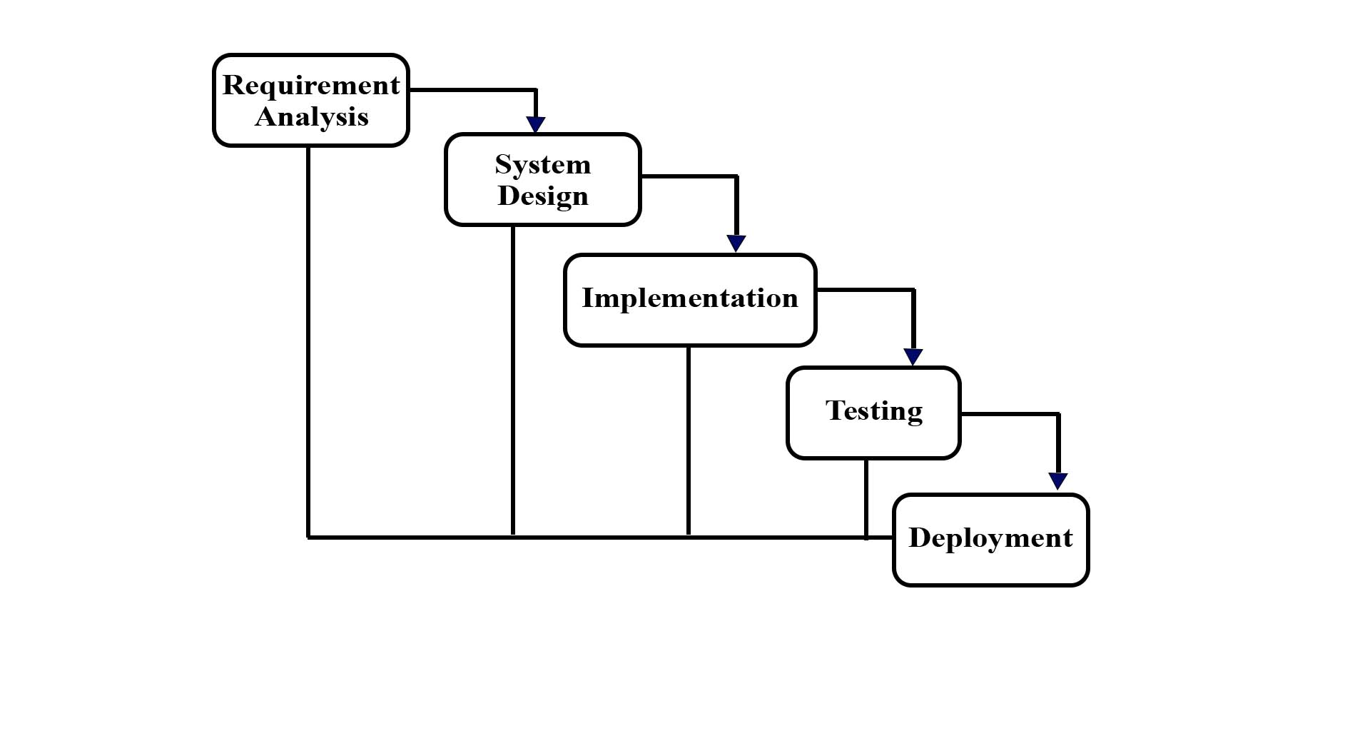Maintenance after deployment

Figure 3-1: Waterfall Software Development Model of IS

### Requirement Analysis

The system’s requirement can be defined as the gathering or collection of the requirements which is done before the project is started. It is the information about the needs and expectations of the stakeholders that helps to meet the specific goal or objective of the organization. It is important for a company to develop a successful project. It includes identifying, analyzing, and organizing the requirements gathered from users or stakeholders.

There are two types of requirement analysis that are mentioned below:

* + - 1. Functional Requirements

The system asks for user’s personal details such as user’s name, address, mobile number, email, etc. User can make booking appointments for bike servicing and maintenance, and buy products as well. Similarly, admin can add, update, retrieve and delete the products. Admin can give necessary response to the requests sent by the customers to the system. All these information is stored in the database.

* + - * 1. **Creation:** This function creates a record for a new customer as well as helps in adding new products, categories, bookings, services in the system.
        2. **Deletion:** This function is used to delete the existing record of any customers as well as the products, categories, bookings, services from the system.
        3. **Update:** This function updates the information of existing records like products, categories, etc.
        4. **Retrieval of data:** This function displays the details of the customers, products, categories, bookings, services, etc.

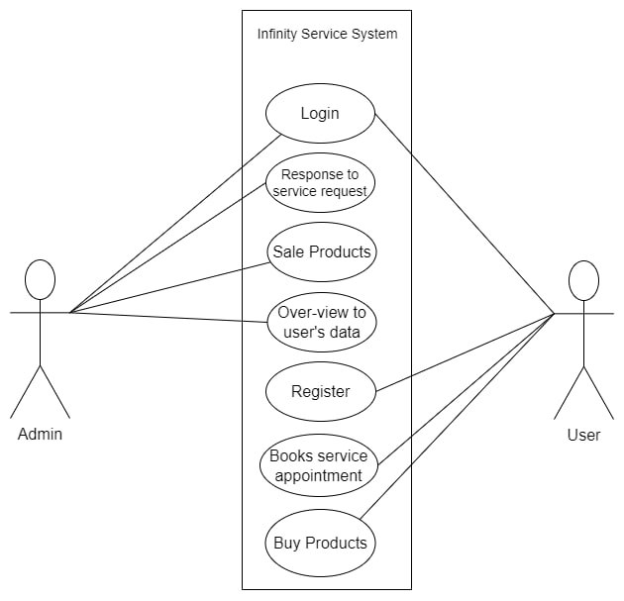

Figure 3-2: Use Case Diagram of IS

* + - 1. Non-Functional Requirements

Non-functional requirements of the system describe the quality attributes that includes performance, security, availability, reliability, usability, as well as maintainability of the system.

* + - * 1. **Security:** Only authorized users with valid username and password can access the system is ensured.
        2. **Performance:** Easy booking of appointments for bike servicing and maintenance and updating with fast responses can be done.
        3. **Maintainability:** Since all data are saved in the database, backups of data are possible.
        4. **View:** Users can easily view the booked appointment status as well as ordered products.
        5. **Availability:** The system should be available 24*7 for the users.

### Feasibility Study

* + - 1. Technical Feasibility Study

This project is totally an online based website. The major tools and technologies which are used in this system to make this project feasible are:

Table 3-1: Technical Feasibility Study Table

|  |  |  |
| --- | --- | --- |
| **Technological requirements** | **Hardware requirements** | **Software requirements** |
| HTML, CSS | Laptop | Window 10 OS |
| JavaScript, jQuery, Bootstrap | Keyboard | XAMPP Server |
| MYSQL, PHP | Mouse | MS Word |

Most of the tools and technologies used during completion of this project are freely and readily available. So, this project is technically feasibility.

* + - 1. Operational Feasibility Study

The operational feasibility of the system can also be done same as technical feasibility. It helps in making informed decisions about whether to proceed with the project, modify the project plan, etc. If the system is not efficient, it will not produce the expected benefits. So, there is operational feasibility to run this project.

* + - 1. Economic Feasibility Study

The cost of developing and launching this project at the initial phase is moderate. Technologies required and cloud services can be purchased easily in today’s market. We need a laptop and a working internet connection to run the system.

* + - 1. Schedule Feasibility Study

The schedule feasibility study of the system ensures that the project should not only be feasible in terms of their objectives and goals but it also should be feasible in terms of the time frames. These time frames determine the time in which the project should be achieved.

Every project must finish within predetermined deadline and these can only be considered as a successful project. A Gantt chart is a graphical representation of the activities and durations of the overall project. It represents the schedule and timeline of the project in which goal of the project should be achieved. This online booking system begins with system requirements. Then, the system design of the project is only developed after the requirements are fully gathered within a month. And the further steps are performed in the following schedules:

Table 3-2: Scheduling Table of IS

|  |  |  |  |  |  |  |  |  |  |  |
| --- | --- | --- | --- | --- | --- | --- | --- | --- | --- | --- |
| **Work** | | | | **Starting Date** | | | | **Ending Date** | | |
| Requirement analysis | | | | 28th March 2023 | | | | 26th April 2023 | | |
| System Design | | | | 27th April 2023 | | | | 1st June 2023 | | |
| Implementation | | | | 2nd June 2023 | | | | 15th August 2023 | | |
| Integration and Testing | | | | 16th August 2023 | | | | 25th September 2023 | | |
| Deployment of System | | | | 26th September 2023 | | | | 5th October 2023 | | |
| Work | Month | | | | | | | | | |
| March | April | | May | June | July | August | September | October | |
| Requirement analysis |  |  | |  |  |  |  |  |  | |
| System Design |  |  | |  |  |  |  |  |  | |
| Implementation |  |  | |  |  |  |  |  |  | |
| Integration and testing |  |  | |  |  |  |  |  |  | |
| Deployment of System |  |  | |  |  |  |  |  |  | |

Figure 3-3: Gantt Chart of IS

Since this developed project was made using waterfall model of traditional SDLC, all the requirements were pre-defined in the initial phase of the project. The initial requirements of this project were well-defined. For this it took more than a month to collect and ensure them. It started at the end of the March i.e., 28th March 2023 and ended at 26th April 2023. Similarly, system design took place from 27th April 2023 to 1st June 2023, implementation from 2nd June 2023 to 15th August 2023, integration and testing from 16th August 2023 to 25th September 2023 and deployment and system from 26th September 2023 to 5th October 2023.

### Data Modeling (ER-Diagram)

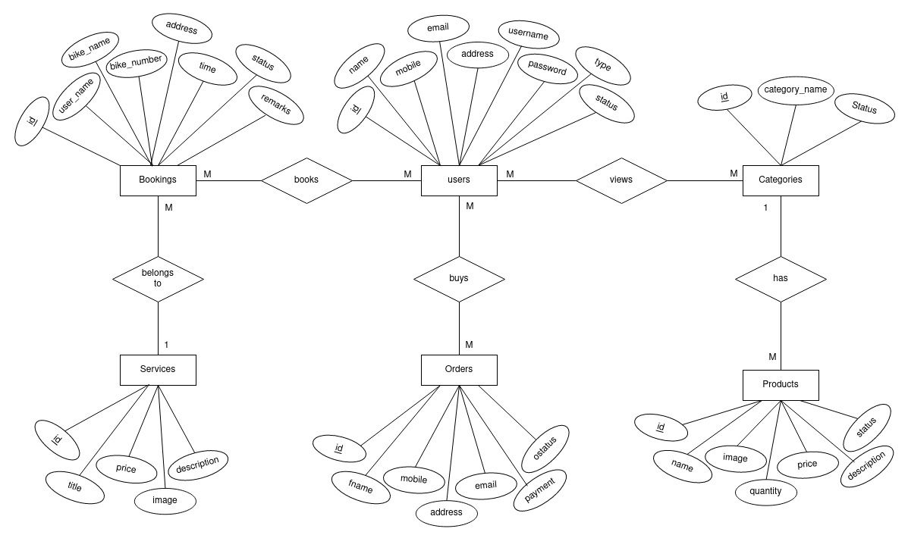

Figure 3-4: ER Diagram of IS

The above ER diagram of IS system depicts five entities with their respective attributes. Entities like users, Categories, Products, Orders, etc have their own attributes with id as primary key for each of them. The entity ‘users’ views different categories from ‘Categories’ which has many products in the entity ‘Products’. Users order different products which is saved in the entity ‘Orders’. Users can also book appointments for different services offered by the system through ‘Services’ entity.

### Process Modeling (DFD)

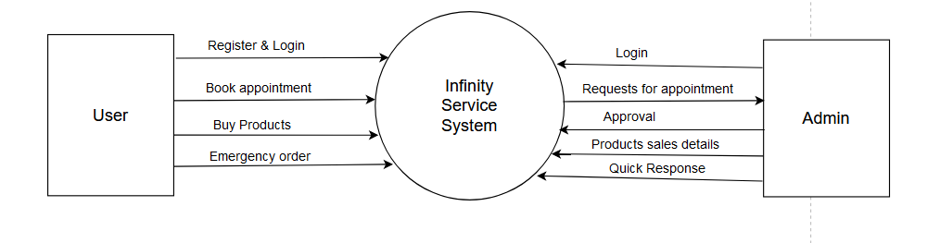

Figure 3-5: Context diagram for IS

This context level diagram of the system shows that the users can register and then login in the system. After appropriate validation from the system, users can fill up the form for booking appointments to get facilities of different services as well as to buy spare parts. All these requests are shown in the dashboard and the service providers (workshops) can handle them.

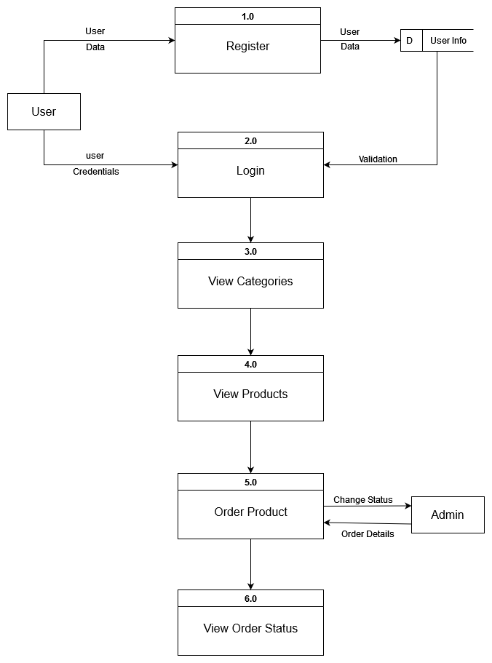

Figure 3-6: DFD level 1 diagram for ordering products

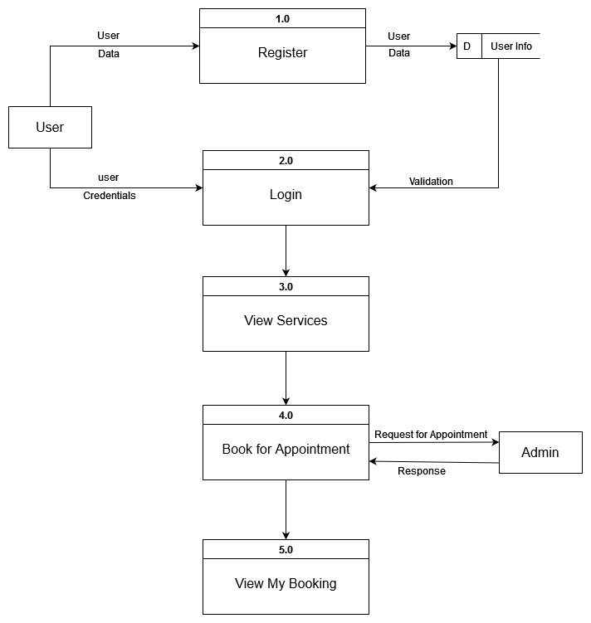

Figure 3-7: DFD level 1 diagram for booking appointments

The above figures of DFD level 1 diagrams represent more detailed step-wise processes to order spare parts as products and to book appointments for bike servicing and maintenance. The users can view different categories after proper validation from the database and then select their required products which are essential during service and maintenance to make an order, that is further handled by the admin. Similarly, in the second diagram of level 1 DFD the logged-in users can select the services and make an appointment request to the system. All these orders and bookings can view from their respective view options.

## System Design

### Architectural Design

The IS system is an online based system. Thus, it requires a database to store all necessary information about inventories of spare parts, users’ details, bookings and ordered details securely. Hence, it uses client-server architecture in which modules are maintained independently. These modules include presentation layer, application layer and database layer. These modules are logically separated from each other.

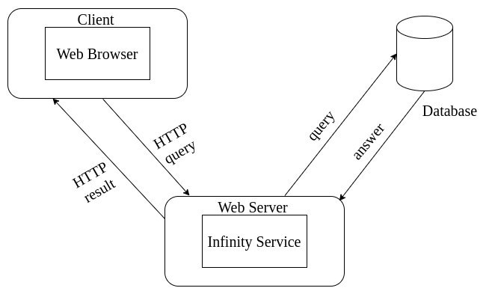Presentation layer is also called as client layer. This layer contains user interface where they can view the applications. By using this layer, users can communicate with all other layers. Application layer acts mediator layer between user interface and database. This contains all business logics like validation of data, insertion and deletion of the data. Similarly, the database layer stores all data and performs tasks like retrieval of data according to the user requests or inputs.

Figure 3-8: Three-Tier Architecture of IS

### Database Schema Design

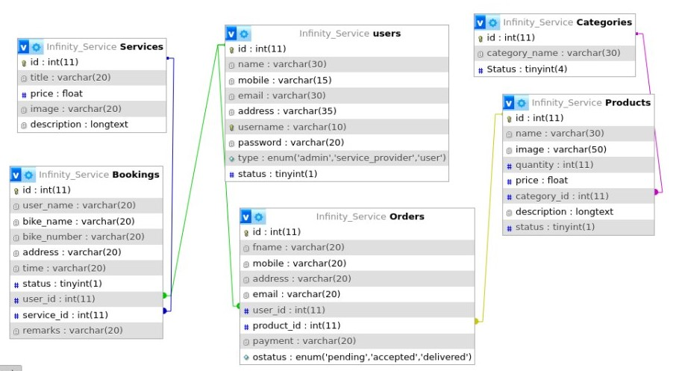

Figure 3-9: IS Schema Design of IS

The above figure is the IS system generated database schema. It shows that the system has database name as Infinity Service with schemas users, Bookings, Categories, Orders, Products and Services which store detailed information about personal details of users, inventories of spare parts, bookings and ordered records in their respective table.

### Interface Design (UI Interface/Interface Structure Diagrams)



Figure 3-10: Index Design of IS

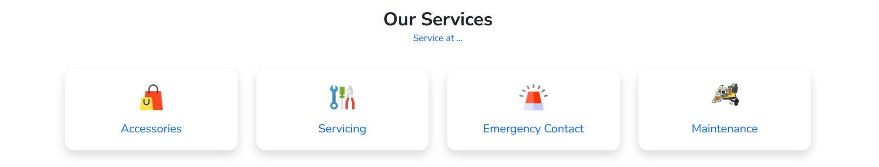

Figure 3-11: Service Section in Index page of IS

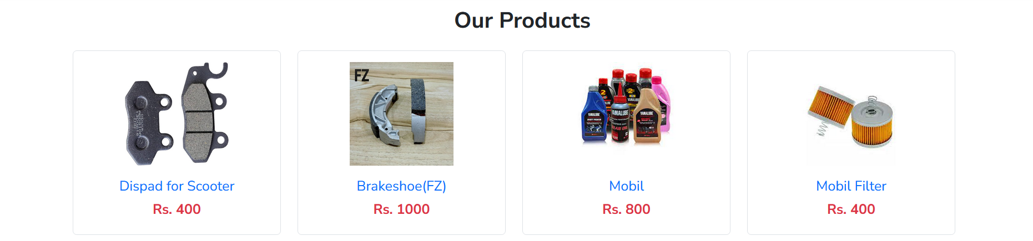

Figure 3-12: Our Product Section in Index page of IS



Figure 3-13: Footer Section in Index page of IS

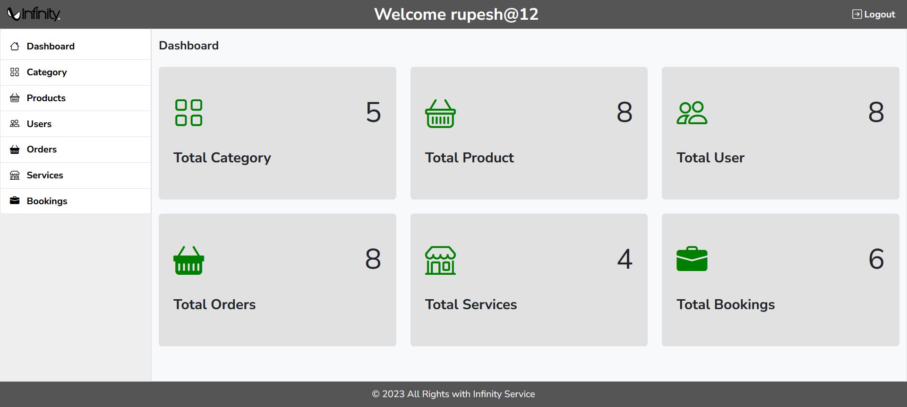

Figure 3-14: Admin Dashboard Design of IS

The above interface diagram of IS system represents the interactions between different components of the system. From the figure of interface diagram, after proper registration and login all components are shown. To order products, users can navigate the ‘Products’ component from Home and then select the necessary categories and order products. Furthermore, users can book appointments from ‘Service & Maintenance’ component which provides a form to fill up.

Similarly, users can view their respective bookings and orders of the products from my bookings and my orders component respectively.

### Physical DFD

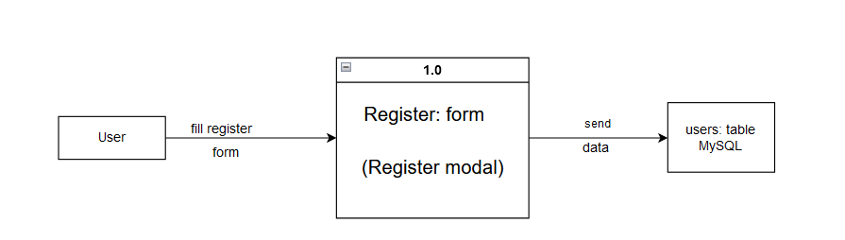

Figure 3-15: Physical DFD for user register

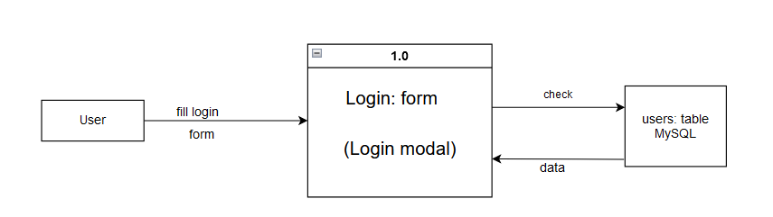

Figure 3-16: Physical DFD for user login

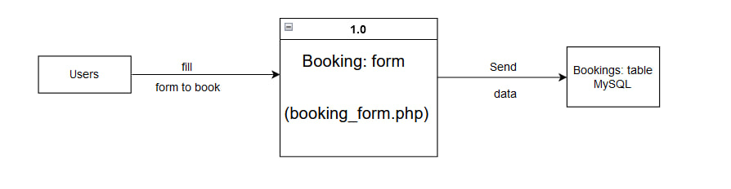

Figure 3-17: Physical DFD for bookings

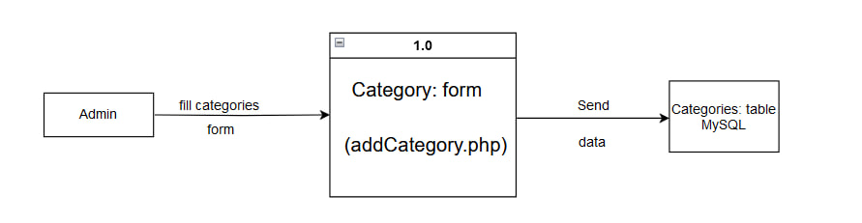

Figure 3-18: Physical DFD for Category

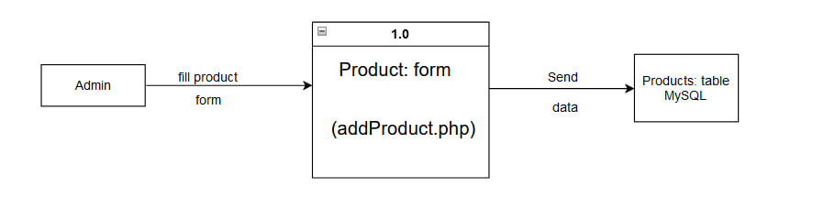

Figure 3-19: Physical DFD for Product

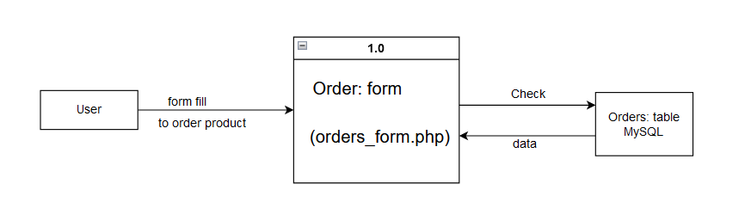

Figure 3-20: Physical DFD for Order

From the above figures of the physical DFD of the system, the users can register into the system and then login to fill up the form to book appointments easily and quickly and to order the products from the system. The admin can login, add categories, products into the system.

# CHAPTER 4: IMPLEMENTATION AND TESTING

## Implementation

Implementation involves different tools and technologies such as HTML5, CSS, JavaScript, jQuery Bootstrap, PHP, XAMPP and MySQL server as discussed above.

### Tools Used

This online booking system is a web-based system which is designed to book bike servicing and maintenance appointments. HTML5, CSS, JavaScript, Bootstrap, and jQuery are used to design the front-end of the system. HTML5 is used to give the structure to the web pages and rest of them are used to give appropriate style, attractive and dynamic design to the system with their pre-defined components.

Similarly, PHP and SQL queries are used in the back-end of the system. This system is based on CRUD operation to insert data into database, update the existing data and delete whenever required. XAMPP is used to access Apache and MySQL server to run this system in localhost. Likewise, MS Word is used for the documentation purpose of the system.

### 4.1.2. Implementation Details of Modules

Some of the major modules of this system are mentioned below:

1. **Header:** This system includes the header module in which logo of the website and different navigation icons with their functioning links, for respective pages, are shown.
2. **Slider:** This module helps to display the ads and images related to the website. Different types of products can be shown with the help of this module.
3. **Register Form:** This module helps the bike owners to get registered in the system. It includes fields like full name, address, mobile, email address, etc.
4. **Login Form:** This module helps the system’s users to get logged in to the system. This is performed after appropriate validation like login credentials that are already saved in the database.
5. **Booking Module:** This module helps this system to book appointments easily and quickly for reliable and convenience servicing and maintenance. This helps the bike owners to select different type of services.
6. **Order Module:** This module helps the users to select their required category-wise products and track the order.
7. **Add Module:** This module helps the service providers to add new service, categories, and products into the system.

## Testing

Software Testing is a method to check whether the actual software product matches expected requirements and to ensure that software product is Defect free. Testing identifies important defects, flaws, or an error in the application code that must be fixed. It also assesses the feature of a system. Testing assesses the quality of the product.

For the testing of the system, we used different test cases for unit testing and system testing as below:

### 4.2.1 Test Case for Unit Testing

**1. Register page test case**

Table 4-3: Register page Test Case

|  |  |  |  |  |  |
| --- | --- | --- | --- | --- | --- |
| **T.C. No.** | **Test Scenario** | **Test Data** | **Expected Output** | **Actual Output** | **Result (Pass/Fail)** |
| 1.1 | User enters digits in full name field, - and digits in address field, invalid email format in email address field, letters with not equal to 10 digits in mobile field, username field without @ followed by digits, password field less than length 6 | Full Name: Dharmu23  Address: Bafal-2  Email Address: dharmu12gmail.com  Mobile:98123345as  Username: dharmu12  Password: 12345 | Register Successful | Full name must be letters only, address must be in letters, email address in valid email format, mobile must be 10 digits only, username with @ followed by digits, password must be at least 6 in length | Fail |
| 1.2 | Enters full name in letters only, address in letters, valid email address format, mobile in 10 digits only, username with @ followed by digits, password at least 6 in length | Full Name: Dharmu Ram  Address: Bafal  Email Address: dharmu12@gmail.com  Mobile:9812345678  Username: dharmu@12  Password: 123456 | Register Successful | Register Successful | Pass |

**2. Login page test case**

Table 4-4: Login page Test Case

|  |  |  |  |  |  |
| --- | --- | --- | --- | --- | --- |
| **T.C. No.** | **Test Scenario** | **Test Data** | **Expected Output** | **Actual Output** | **Result**  **(Pass/Fail)** |
| 2.1 | User Enters an invalid username and valid Password | Username: dharmu12  Password:123456 | Login successful | Wrong Credentials | Fail |
| 2.2 | User Enters valid username and invalid Password | Username: dharmu@12  Password: 12345678 | Login successful | Wrong Credentials | Fail |
| 2.3 | User Enters a valid username and valid Password | Username: dharmu@12  Password: 123456 | Login successful | Login successful | Pass |

**3. Service and Maintenance page test case**

Table 4-5: Service and Maintenance page Test Case

|  |  |  |  |  |  |
| --- | --- | --- | --- | --- | --- |
| **T.C. No.** | **Test Scenario** | **Test Data** | **Expected Output** | **Actual Output** | **Result (Pass/Fail)** |
| 3.1 | Books with null service, Without Session, Bike Number with invalid pattern, past time in Time field | Service: null  Bike Number: pa02003@4  Time: 09/17/2023,09:00 AM | Booking added | Must select a service option, must logged in, must be in valid bike number pattern, Time must be in future | Fail |
| 3.2 | Enter already booked date and time | Bike Number: Pa-03-003-5678  Time: 10/17/2023,09:00 AM | Booking added | Already booked. Please select time after adding 30 minutes | Fail |
| 3.3 | Books with service, with user Session, Bike Number with valid pattern, future time which is not booked yet | Service: Servicing  Bike Number: Pa-03-003-5678  Time: 10/17/2023,09:30 AM | Booking added | Booking added | Pass |

**4. Order page test case**

Table 4-6: Order page Test Case

|  |  |  |  |  |  |
| --- | --- | --- | --- | --- | --- |
| **T.C. No.** | **Test Scenario** | **Test Data** | **Expected Output** | **Actual Output** | **Result (Pass/Fail)** |
| 4.1 | Order Placed without Session, full name with digits, mobile number with strings, address with combination of digits and letters, invalid email address | Full Name: Dharmu12  Mobile Number: 9874hj09  Address: Bafal2  Email Address: dharmu12gmail.com | Requested | Must be logged in, full name must not include digits, mobile number must be digits only, address must be in letters only, email address must be valid | Fail |
| 4.2 | Order Placed with Session, full name with strings, mobile number with digits, address in strings, valid email address | Full Name: Dharmu Ram  Mobile Number: 9812345678  Address: Bafal  Email Address: dharmu12@gmail.com | Requested | Requested | Pass |

### System Testing

System Testing is a level of testing that validates the complete and fully integrated software product. The purpose of a system test is to evaluate the end-to-end system specifications.

**5. System test case**

Table 4-7: System Test Case

|  |  |  |  |  |
| --- | --- | --- | --- | --- |
| **T.C. No.** | **Test Scenario** | **Expected Output** | **Actual Output** | **Result (Pass/Fail)** |
| 5.1 | All the components and units should be integrated as a whole into a single website and work interactively on basis of data sent from database on basis of user’s request. | The backend will be sending response in JSON format and displayed on user friendly view on frontend where user can interact. | Data from database was retrieved from backend in JSON and was displayed well in frontend. All the units were well coupled and working together as per user’s request. | Pass |

# CHAPTER 5: CONCLUSION AND FUTURE RECOMMENDATIONS

## Lesson Learnt / Outcome

Our Infinity Service is able to create an environment for end users to book appointments for servicing and maintenance at user’s convenience date and time. The users can easily book a schedule by filling up the form at their trusted and reliable service provider. Similarly, service providers can record inventories digitally. The users can also buy product at the time servicing.

Also, by working on this project we learned a lot of things like web application development using HTML, CSS, JavaScript, jQuery, PHP and MySQL. We learnt to make a proper documentation and this project also helped us to develop our skills in many ways.

## Conclusion

The project Infinity Service is the complex filed and encompasses technical skills along with management. Project are influenced by both internal and external factors and required various communication and techniques to reduce the gap and deliver project effectively and efficiently. The project has their own challenges due to the advance technologies etc.

## Future Recommendations

In this part, we purpose recommendations that promote online web-based booking system.

1. Add to cart option.
2. Optimal procedure for an item.
3. Use of chat box to make two-way communication between the bike owner and the service provider.
4. Payment gateway.

# REFERENCES

|  |  |
| --- | --- |
| [1] | third wheel pvt. ltd., "Third Wheel," 03 08 2018. [Online]. Available: https://thirdwheel.com.np/. |

# APPENDICES

